Permissions overview
The purpose of a permission is to protect the privacy of an Android user. Android apps must request permission to access sensitive user data (such as contacts and SMS), as well as certain system features (such as camera and internet). Depending on the feature, the system might grant the permission automatically or might prompt the user to approve the request.
This page provides an overview to how Android permissions work, including: how permissions are presented to the user, the difference between install-time and runtime permission requests, how permissions are enforced, and the types of permissions and their groups.

Permission approval
An app must publicize the permissions it requires by including <uses-permission> tags in the app manifest.
For example, an app that needs to send SMS messages would have this line in the manifest:
<manifest xmlns:android="http://schemas.android.com/apk/res/android"
package="com.example.snazzyapp">
<uses-permission android:name="android.permission.SEND_SMS"/>
<application ...>
...
</application>
</manifest>
If your app lists normal permissions in its manifest (that is, permissions that don't pose much risk to the user's privacy or the device's operation), the system automatically grants those permissions to your app.
If your app lists dangerous permissions in its manifest (that is, permissions that could potentially affect the user's privacy or the device's normal operation), such as the SEND_SMS permission above, the user must explicitly agree to grant those permissions.

Request prompts for dangerous permissions
Only dangerous permissions require user agreement. The way Android asks the user to grant dangerous permissions depends on the version of Android running on the user's device, and the system version targeted by your app.

Runtime requests (Android 6.0 and higher)
If the device is running Android 6.0 (API level 23) or higher, and the app's targetSdkVersion is 23 or higher, the user isn't notified of any app permissions at install time. Your app must ask the user to grant the dangerous permissions at runtime. When your app requests permission, the user sees a system dialog (as shown in figure 1, left) telling the user which permission group your app is trying to access. The dialog includes a Deny and Allowbutton.
If the user denies the permission request, the next time your app requests the permission, the dialog contains a checkbox that, when checked, indicates the user doesn't want to be prompted for the permission again (see figure 1, right).
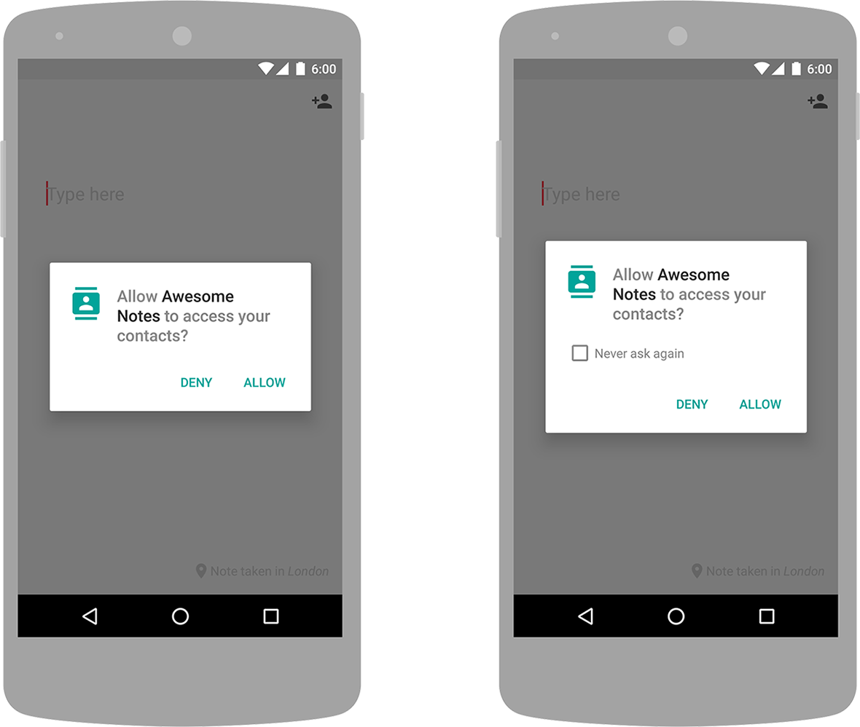
Figure 1. Initial permission dialog (left) and secondary permission request with option to turn off further requests (right)
If the user checks the Never ask again box and taps Deny, the system no longer prompts the user if you later attempt to requests the same permission.
Even if the user grants your app the permission it requested you cannot always rely on having it. Users also have the option to enable and disable permissions one-by-one in system settings. You should always check for and request permissions at runtime to guard against runtime errors (SecurityException).

.

Install-time requests (Android 5.1.1 and below)
If the device is running Android 5.1.1 (API level 22) or lower, or the app's targetSdkVersion is 22 or lower while running on any version of Android, the system automatically asks the user to grant all dangerous permissions for your app at install-time (see figure 2).
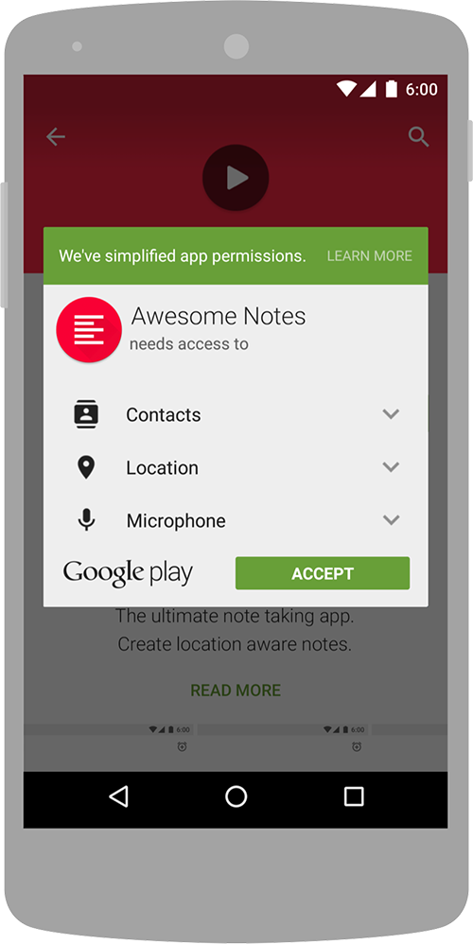
Figure 2. Install-time permission dialog
If the user clicks Accept, all permissions the app requests are granted. If the user denies the permissions request, the system cancels the installation of the app.
If an app update includes the need for additional permissions the user is prompted to accept those new permissions before updating the app.
For an overview of the recommended user experience patterns for requesting permissions, see App Permissions Best Practices.

